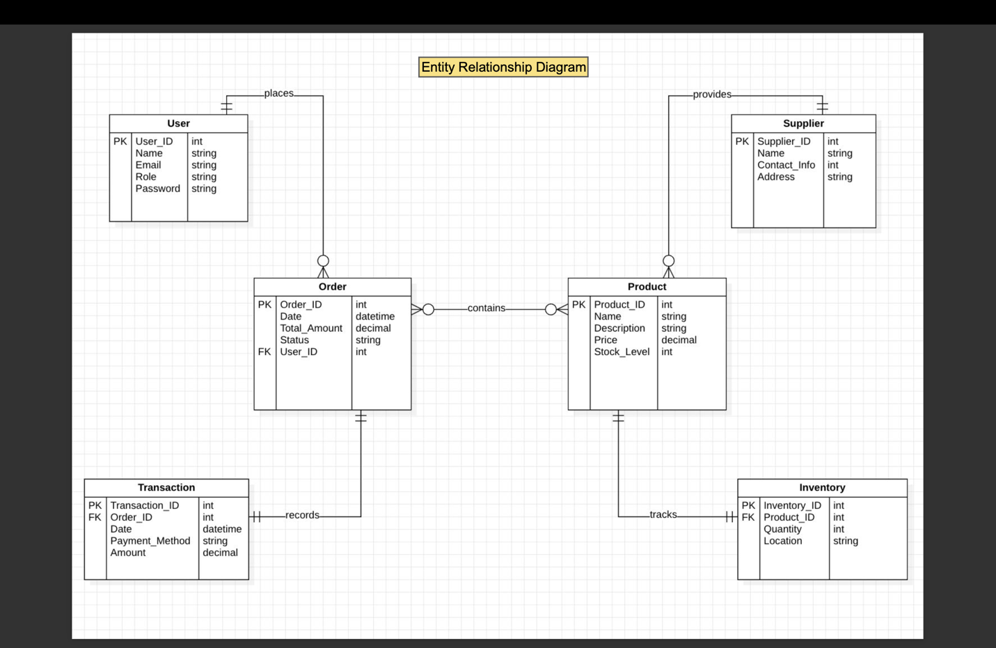

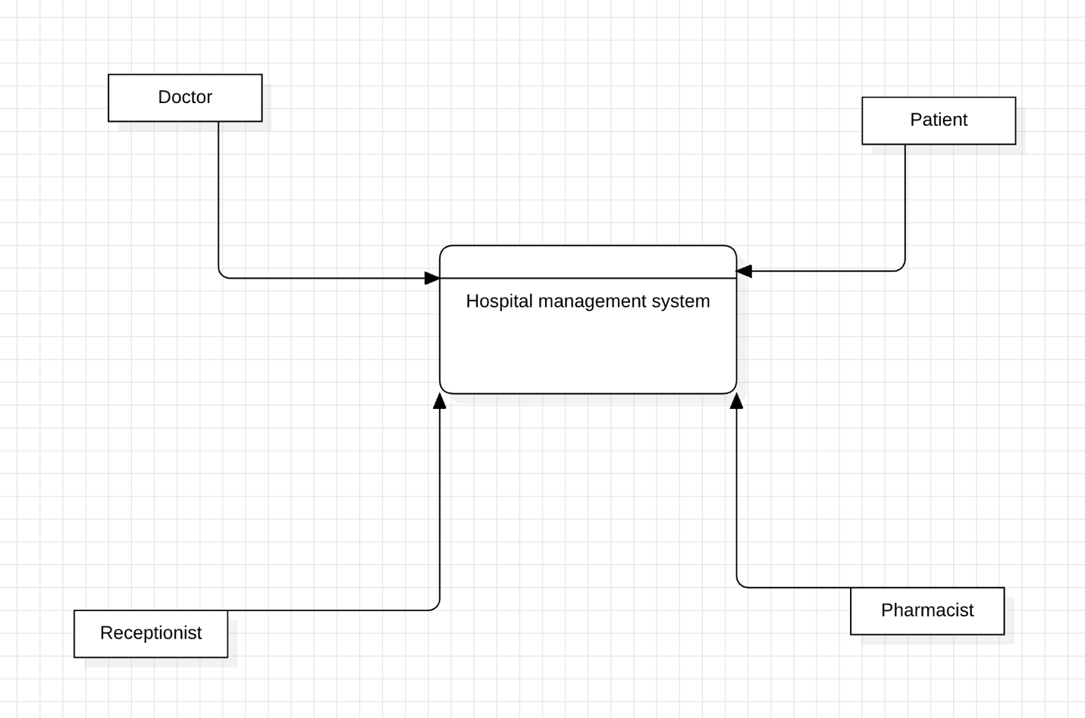

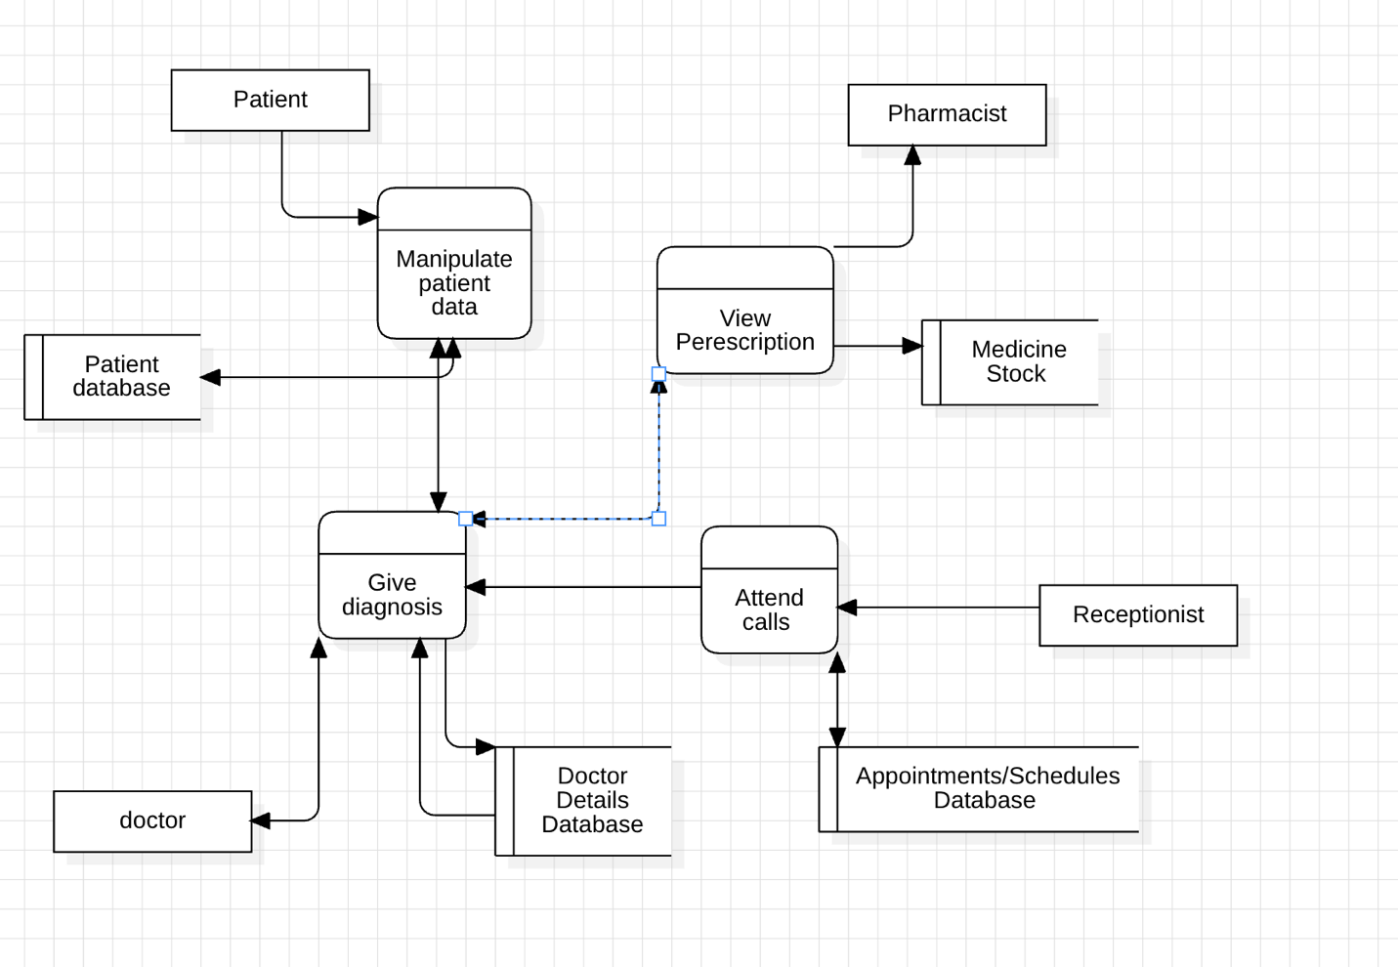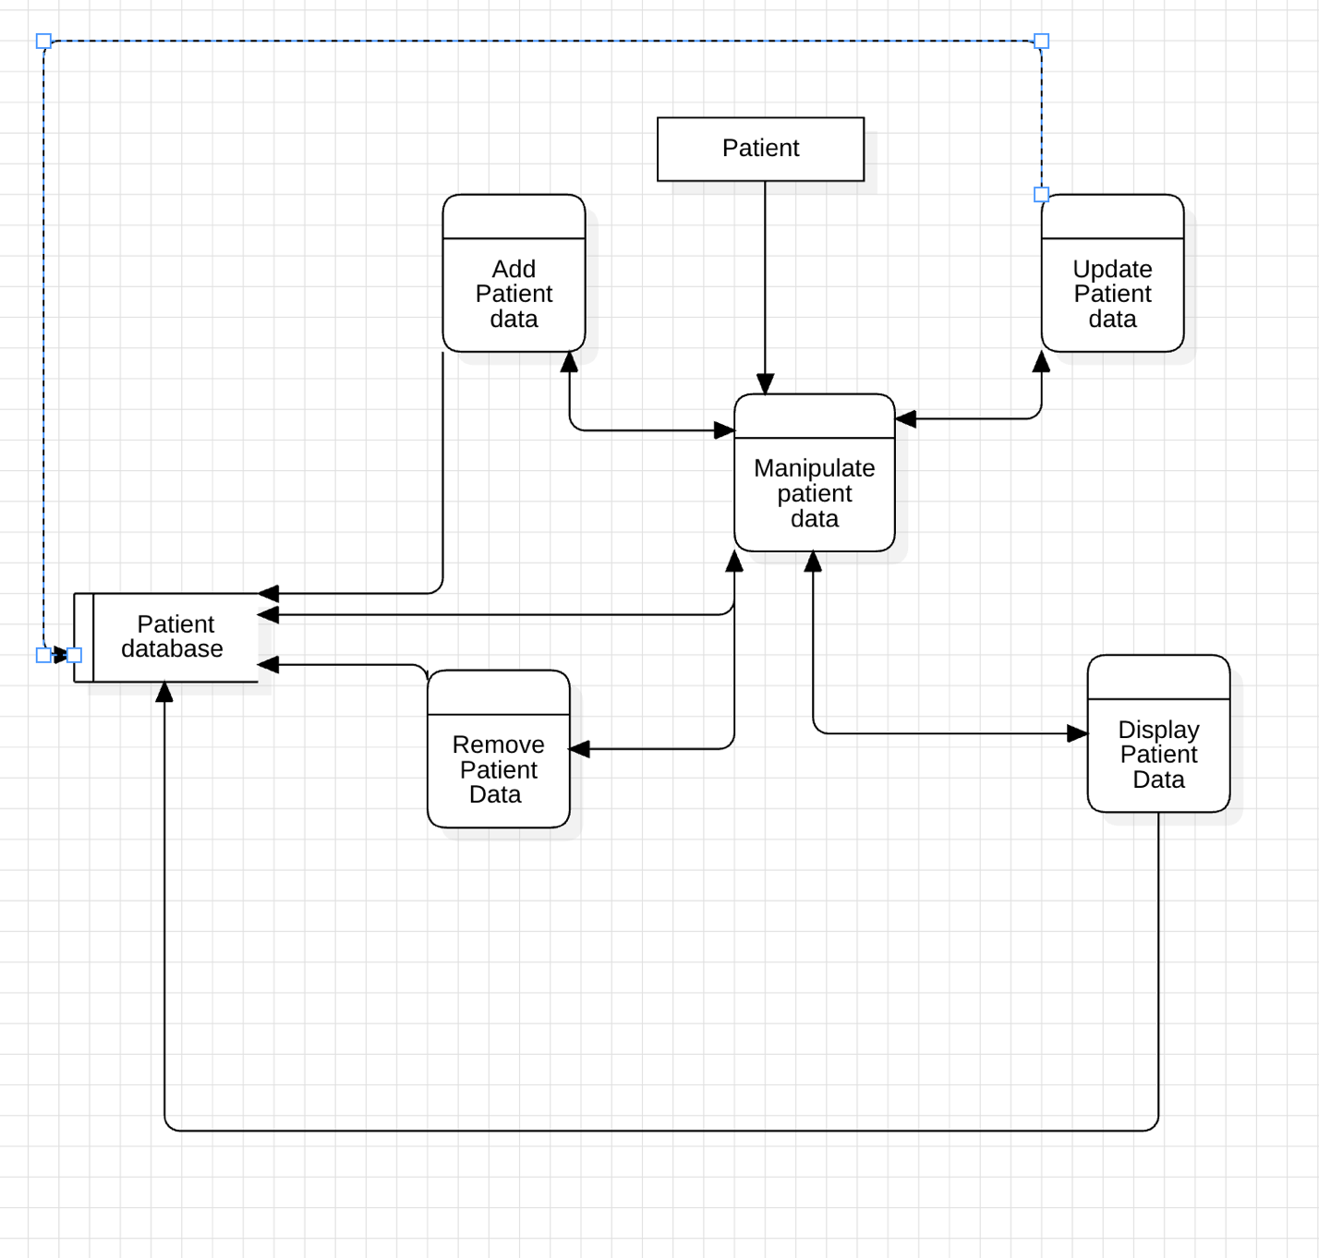









Use Case Diagram for inventory management

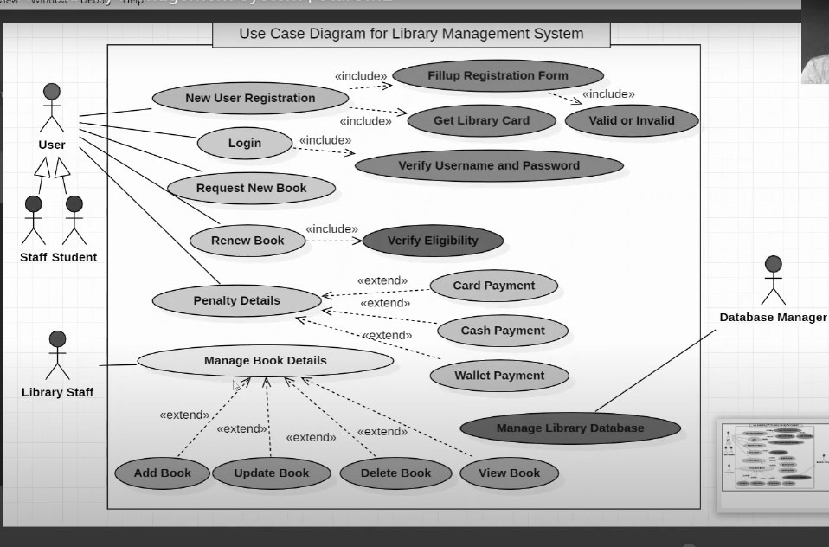

Class Diagram for inventory management

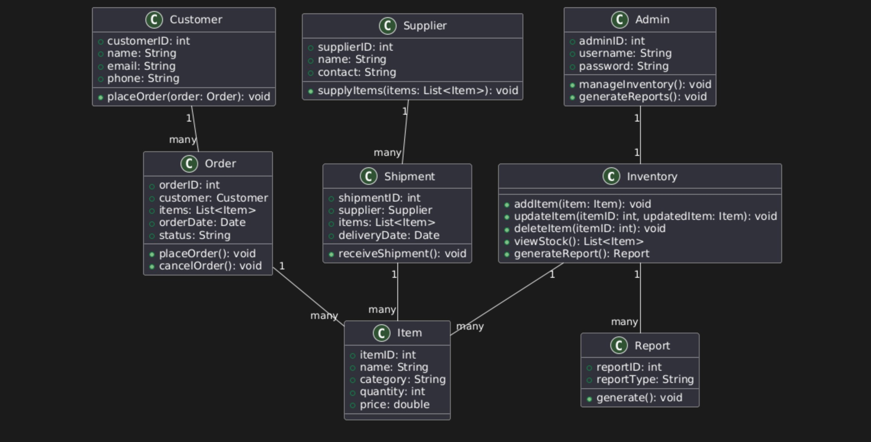

**Software Requirements Specification**  
**for**  
**Inventory Management System**

**Version 1.0 Approved**

**Prepared by**

Jayesh Pani (Reg. No.: 23MIC0059)

**Table of Contents**

1. Introduction ......................................................................................................................3  
   1.1 Purpose .......................................................................................................................3  
   1.2 Document Conventions ..............................................................................................3  
   1.3 Intended Audience and Reading Suggestions ............................................................3  
   1.4 Project Scope ..............................................................................................................3  
   1.5 References ..................................................................................................................3
2. Overall Description ..........................................................................................................4  
   2.1 Product Perspective ....................................................................................................4  
   2.2 Product Features .........................................................................................................4  
   2.3 User Classes and Characteristics ................................................................................4  
   2.4 Operating Environment ..............................................................................................4  
   2.5 Design and Implementation Constraints ....................................................................4  
   2.6 User Documentation ..................................................................................................5  
   2.7 Assumptions and Dependencies ................................................................................5
3. System Features ...............................................................................................................5  
   3.1 User Authentication ...................................................................................................5  
   3.2 Inventory Tracking ....................................................................................................5  
   3.3 Order Management ....................................................................................................5  
   3.4 Reporting and Analytics ............................................................................................6  
   3.5 Supplier Management ................................................................................................6  
   3.6 Inventory Forecasting ................................................................................................6  
   3.7 Multi-Location Inventory Support .............................................................................6  
   3.8 User Role Management .............................................................................................6
4. External Interface Requirements .....................................................................................6  
   4.1 User Interfaces ...........................................................................................................6  
   4.2 Hardware Interfaces ..................................................................................................6  
   4.3 Software Interfaces ....................................................................................................7  
   4.4 Communications Interfaces .......................................................................................7
5. Nonfunctional Requirements ...........................................................................................7  
   5.1 Performance Requirements .......................................................................................7  
   5.2 Safety Requirements .................................................................................................7  
   5.3 Security Requirements ..............................................................................................7  
   5.4 Software Quality Attributes ......................................................................................7
6. Other Requirements ........................................................................................................8
7. Appendices ......................................................................................................................8  
   Appendix A: Glossary .....................................................................................................8  
   Appendix B: Analysis Models ........................................................................................8  
   Appendix C: Issues List ..................................................................................................8

**Revision History**

|  |  |  |  |
| --- | --- | --- | --- |
| **Date** | **Version** | **Description** | **Author** |
| 5-02-2025 | 1 | Initial draft | Jayesh Pani |
|  |  |  |  |

**1. Introduction**

**1.1 Purpose**

The purpose of this document is to define the functional and non-functional requirements for the **Inventory Management System (IMS)**. This document serves as a reference for developers, testers, and stakeholders to ensure that the software meets all business objectives and technical constraints. The IMS is intended to streamline inventory tracking, order management, and supply chain logistics for organizations that require real-time inventory visibility.

**1.2 Document Conventions**

* Requirements prefixed with "FR" indicate **Functional Requirements** that define what the system should do.
* Requirements prefixed with "NFR" indicate **Non-Functional Requirements** that define constraints, performance, and quality attributes.
* Diagrams and tables are used to enhance clarity where applicable.

**1.3 Intended Audience and Reading Suggestions**

This document is intended for:

* **Software Developers**: To understand the functional and technical requirements.
* **Test Engineers**: To develop test cases and verify system functionalities.
* **Project Managers**: To oversee system implementation and ensure business alignment.
* **Business Analysts**: To ensure that the documented requirements meet business goals.
* **Stakeholders**: To validate that the system fulfills their expectations.

**1.4 Project Scope**

The **Inventory Management System (IMS)** is designed to efficiently track and manage inventory levels, stock movements, order processing, sales, and deliveries. The system enables businesses to:

* **Automate inventory tracking** to reduce manual errors.
* **Optimize stock levels** to avoid overstocking or stockouts.
* **Generate reports and analytics** to support data-driven decision-making.
* **Enhance customer and supplier relations** with efficient order processing and tracking
* **Enhance security and access control** through role-based authentication.

**1.5 References**

* IEEE Standard for SRS (IEEE Std 830-1998)
* Industry best practices for inventory and supply chain management
* GDPR compliance documentation for data security

**2. Overall Description**

**2.1 Product Perspective**

The IMS replaces traditional, manual inventory tracking methods with an automated, scalable, and cloud-based system. It integrates with existing **ERP (Enterprise Resource Planning) and POS (Point of Sale) systems**, ensuring seamless communication between different business operations.

**2.2 Product Features**

* **Real-time inventory tracking** with automated stock level updates.
* **Multi-location inventory management** for warehouses and store branches.
* **Barcode and RFID integration** for efficient stock identification.
* **Order and supplier management** to streamline procurement and sales.
* **Comprehensive reporting and analytics** for business intelligence.
* **Role-based access control** to ensure secure system usage.

**2.3 User Classes and Characteristics**

* **Inventory Managers**: Oversee stock levels, generate reports, and coordinate reordering.
* **Sales Staff**: Manage order processing and customer interactions.
* **Administrators**: Configure system settings, manage user roles, and handle security.
* **Suppliers**: Provide stock and update order statuses through integration.
* **Customers**: Benefit from timely order fulfillment and accurate stock availability.

**2.4 Operating Environment**

* **Web-based application** with cloud support.
* **Mobile-friendly interface** for Android and iOS devices.
* **Integration with barcode scanners and RFID systems.**
* **Runs on secure, scalable database servers.**

**2.5 Design and Implementation Constraints**

* Must integrate with **ERP and POS systems** for seamless operations.
* Must adhere to **GDPR and PCI DSS** data security standards.
* Should support a minimum of **10,000 concurrent users.**

**2.6 User Documentation**

* User manuals with step-by-step guides.
* Online knowledge base for troubleshooting and FAQs.

**2.7 Assumptions and Dependencies**

* Stable internet connectivity is required for real-time tracking.
* Third-party APIs for supplier and logistics integrations.

**3. System Features**

**3.1 User Authentication**

User authentication is a critical component of the system that ensures that only authorized personnel can access and modify inventory data. The system will support multi-factor authentication (MFA) to add an extra layer of security. Users will be categorized based on roles, such as administrators, inventory managers, and sales staff, ensuring that each has appropriate access levels. The system will log all login attempts and notify administrators of failed attempts to prevent unauthorized access.

**3.2 Inventory Tracking**

The inventory tracking module will allow real-time monitoring of stock levels across multiple locations. Each item will have a unique identifier, and barcode scanning will be integrated for accurate and efficient stock management. Automated alerts will notify managers when stock reaches a predefined threshold, enabling timely restocking. The system will also track expiration dates for perishable goods, reducing waste and preventing stock shortages.

**3.3 Order Management**

Order management will handle purchase orders from suppliers and sales orders from customers. The system will allow businesses to automate order processing, track shipments, and generate invoices. It will support bulk ordering, order cancellation, and modification. Integration with third-party supplier APIs will enable automatic order placement when stock levels fall below the set limit. The system will maintain order histories for auditing purposes.

**3.4 Reporting and Analytics**

Reporting and analytics will provide insights into stock movement, sales trends, and supplier performance. The system will generate real-time reports on stock levels, order status, and revenue trends. Advanced analytics will use predictive modeling to help businesses optimize stock levels and avoid overstocking. Export options for reports will include PDF, Excel, and CSV formats, ensuring compatibility with external accounting systems.

**4. External Interface Requirements**

**4.1 User Interfaces**

The **Inventory Management System (IMS)** will provide an intuitive, interactive, and user-friendly dashboard that offers real-time insights into inventory levels, order statuses, and supplier interactions. The interface will be designed with usability in mind, ensuring ease of navigation even for non-technical users. The system will feature a **role-based dashboard** that customizes content and accessibility based on user roles, such as administrators, inventory managers, and sales staff.

The interface will be **responsive**, meaning it will adapt seamlessly to different screen sizes, ensuring compatibility across **desktops, tablets, and mobile devices**. This ensures that users can access and manage inventory from anywhere, improving efficiency and flexibility. The UI will include **real-time notifications**, charts, and reports, helping users make data-driven decisions quickly.

**4.2 Hardware Interfaces**

IMS will support **barcode scanners and RFID technology** to facilitate rapid stock updates and tracking. Barcode scanning will allow users to quickly add, remove, or adjust inventory, reducing manual errors and increasing efficiency. RFID support will enable automated stock tracking, ensuring precise inventory control in warehouses and retail stores.

Cloud-based storage integration will be implemented to support **secure data access and real-time synchronization**across multiple locations. This ensures that inventory data is always up to date and accessible from various branches or warehouses, eliminating data discrepancies and delays in order processing.

Additionally, IMS will be compatible with **printers for label printing**, allowing businesses to generate barcode labels for stock items, receipts, and invoices. It will also support **weighing scales integration**, particularly for businesses dealing with perishable or weighted inventory, ensuring precise stock measurement.

**4.3 Software Interfaces**

IMS will feature **seamless API integration** with Enterprise Resource Planning (**ERP**), Point of Sale (**POS**), and supplier management systems. The ERP integration will ensure **real-time synchronization** between inventory levels and other business operations, streamlining financial reporting and procurement planning.

The POS system integration will allow automatic stock updates upon each sale, ensuring accurate inventory tracking and preventing overselling. Supplier system integration will enable businesses to **automate restocking**, allowing inventory to be replenished based on predefined stock thresholds and supplier agreements.

Secure payment gateways such as **PayPal, Stripe, or direct bank transfers** will be integrated to facilitate financial transactions related to supplier payments and customer invoicing. The system will ensure **secure financial transactions**with end-to-end encryption and fraud detection measures, complying with financial security standards such as PCI DSS.

**4.4 Communications Interfaces**

IMS will utilize **RESTful APIs** to facilitate communication between internal modules and external systems such as suppliers, third-party logistics providers, and accounting software. These APIs will support **real-time data exchange**, ensuring that inventory levels, order statuses, and financial transactions remain updated without manual intervention.

For real-time notifications and instant updates, IMS will integrate **WebSockets technology**. This will allow **live updates on stock changes, new orders, shipment tracking, and low-stock alerts**, ensuring that relevant stakeholders are always informed. This feature is particularly useful in multi-location businesses where inventory adjustments need to be reflected across all sites instantly.

Email and SMS notification systems will also be incorporated to alert users about critical updates, such as **low inventory warnings, new purchase orders, and delayed shipments**. This will ensure proactive stock management, reducing the risk of stockouts and operational disruptions.

**5. Nonfunctional Requirements**

**5.1 Performance Requirements**

The system should be capable of handling at least 10,000 concurrent users without significant latency. Inventory search queries should return results within 2 seconds under normal operating conditions. The system will use caching mechanisms to enhance response time and optimize database performance. Load balancing techniques will be implemented to distribute traffic efficiently, ensuring high-speed operations even during peak hours.

**5.2 Safety Requirements**

Safety features will ensure that the system is resistant to power failures and other unexpected events. Automated backup mechanisms will be in place to prevent data loss, with backups scheduled daily and stored securely in encrypted cloud storage. In case of hardware failures, the system will support automatic failover to backup servers, ensuring continuous availability. Additionally, an emergency shutdown mechanism will be implemented to prevent data corruption in the event of a system crash.

**5.3 Security Requirements**

Security will be a top priority, ensuring that inventory data remains confidential and protected from unauthorized access. Data encryption using AES-256 will be implemented for all sensitive data. Role-based access control (RBAC) will be enforced to limit user privileges. The system will comply with industry security standards, including GDPR and PCI DSS, ensuring secure handling of financial transactions. Logs of all user activities will be maintained for audit purposes.

**5.4 Software Quality Attributes**

The system will prioritize usability, ensuring that even non-technical users can navigate the interface with ease. A responsive design will ensure compatibility across desktops, tablets, and mobile devices. Scalability will be a key consideration, allowing the system to expand as the business grows. High reliability will be achieved through rigorous testing and failover mechanisms, ensuring minimal downtime. Maintainability will be supported through modular coding practices, allowing for easy updates and feature enhancements.

**6. Other Requirements**

* Future versions will include AI-powered demand forecasting, allowing businesses to predict inventory needs based on historical data.
* The system will support integration with warehouse robotics and automated picking systems.
* Additional support for blockchain-based tracking will be explored for enhanced security and transparency in supply chain management.

**7. Appendices**

**Appendix A: Glossary**

* **IMS:** Inventory Management System
* **ERP:** Enterprise Resource Planning

**Appendix B: Analysis Models**

* **Use Case Diagrams, ERDs.**

**Appendix C: Issues List**

|  |  |  |
| --- | --- | --- |
| **Issue ID** | **Description** | **Status** |
| 1 | Supplier API delays | Open |
| 2 | Incorrect stock level updates | Open |